Steps Required to Update Subnominals across the FCS Solution

Re-Run XrmMigrator
The XrmMigration tool has been upgraded to migrate subnominals from aggregated payments in the FCS system (Dynamics CRM). This reads the existing data from the fct-database-release database and populates Dynamics CRM via the WCF Endpoint.
Instructions on how to do this are below.
The latest source files will need to be downloaded and build with the correct solution configuration (Release).
The command to run the console application is:
XrmMigrator.exe -migration subnominal
Expected Output:
The Console Window should show a verbose output of all subnominals being migrated, and should not be zero. At the time of writing we do not have an accurate estimate of the number of subnominals required to be migrated. Below is an example of 9 subnominals.
There should be no errors logged. If errors are logged it implies that subnominals are missing in Dynamics CRM and would require further investigation.
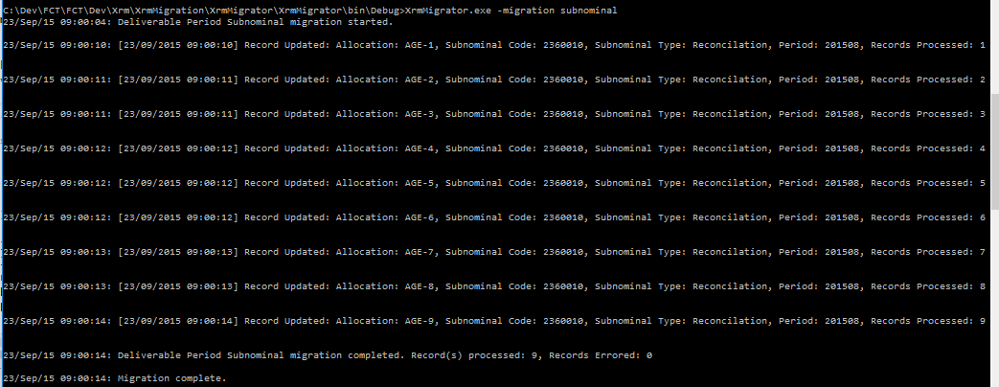
The log file should also include the detail included in the console window. Attached below is an example log for 9 migrations.

